**Step 1 – Project Setup in PartyRock**

📸 *Screenshot 1*

* **Action:** Started a new AWS PartyRock project.
* **Step:** Entered a high-level description of what the app should do: *"An app to process and handle customer escalations for personal loans."*
* **Purpose:** This prompt allows PartyRock to auto-generate an initial app structure, including UI components and logic, based on your description.

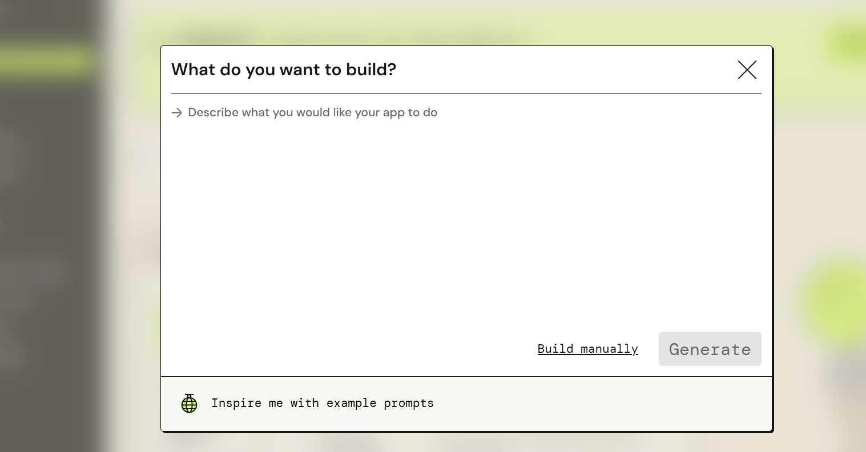

**Step 2 – App Description & Core Functionality**

📸 *Screenshot 2*

* **Action:** Defined the **About This App** section.
* **Step:** Wrote a clear description: *"Helps process and handle customer escalations related to personal loans..."*
* **Purpose:** This acts as both documentation for end users and a design reference for you during development.

**Step 3 – Input Fields & Workflow**

📸 *Screenshot 3*

* **Action:** Added structured input fields:
  + **Customer Name**
  + **Loan Account Number**
  + **Customer Complaint**
* **Purpose:** To capture all necessary case details in a standard format so the AI can analyze them effectively.

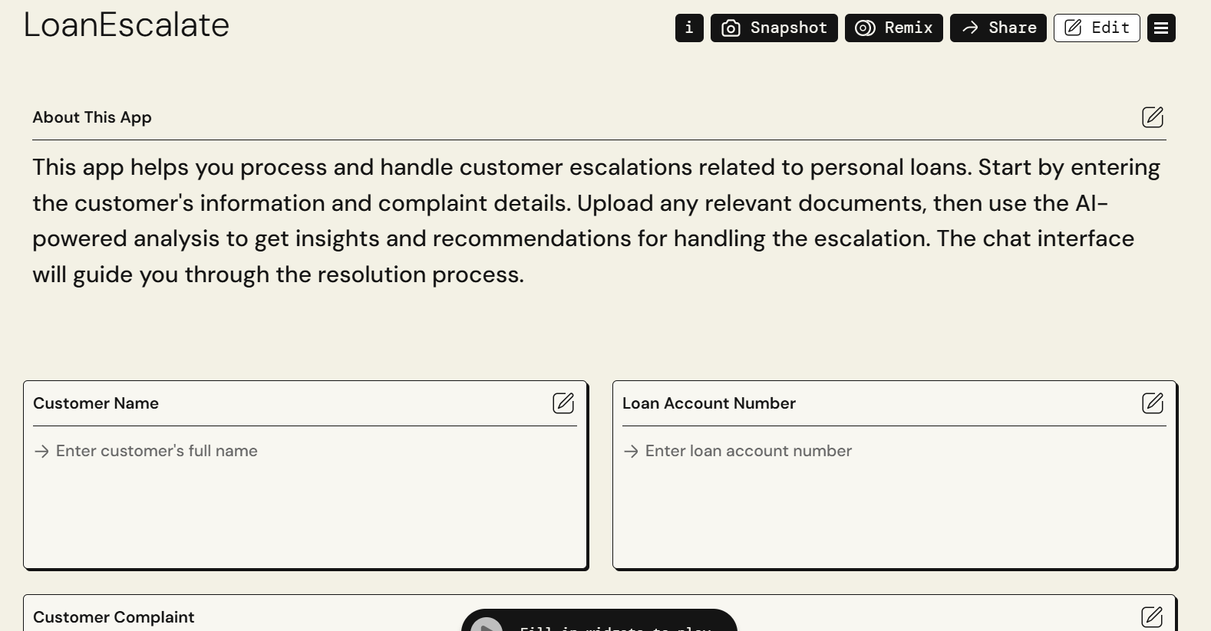

**Step 4 – AI-Powered Analysis**

* **Action:** Configured Party Rock’s AI model (powered by Amazon Bedrock) to process the entered details and documents.
* **Step:** The model generates insights and suggested resolution actions.
* **Purpose:** Speeds up complaint handling and ensures consistent recommendations.

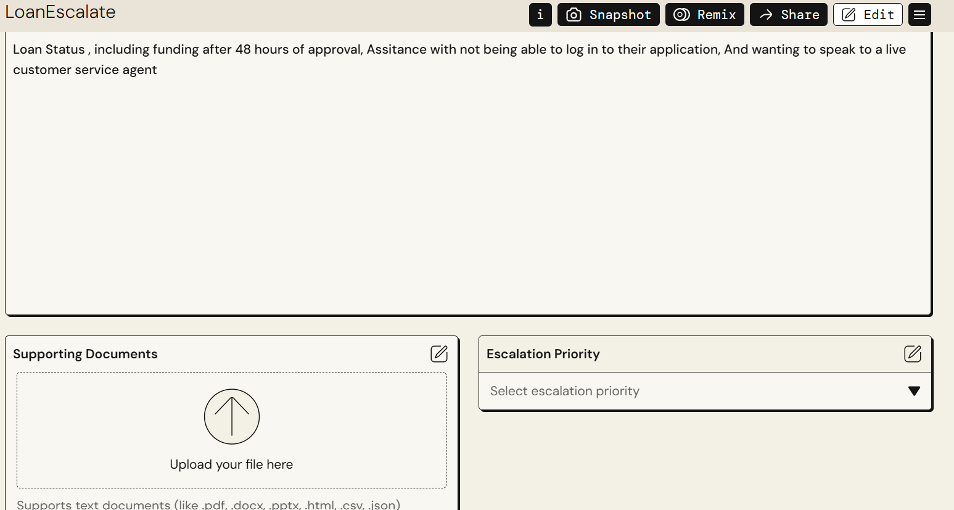

**Step 5 – Guided Resolution via Chat**

(Not pictured but part of app output)

* **Action:** Implemented a conversational AI chat flow to guide the user through resolution steps.
* **Purpose:** Makes the process interactive, ensuring that all required steps are followed without missing details.

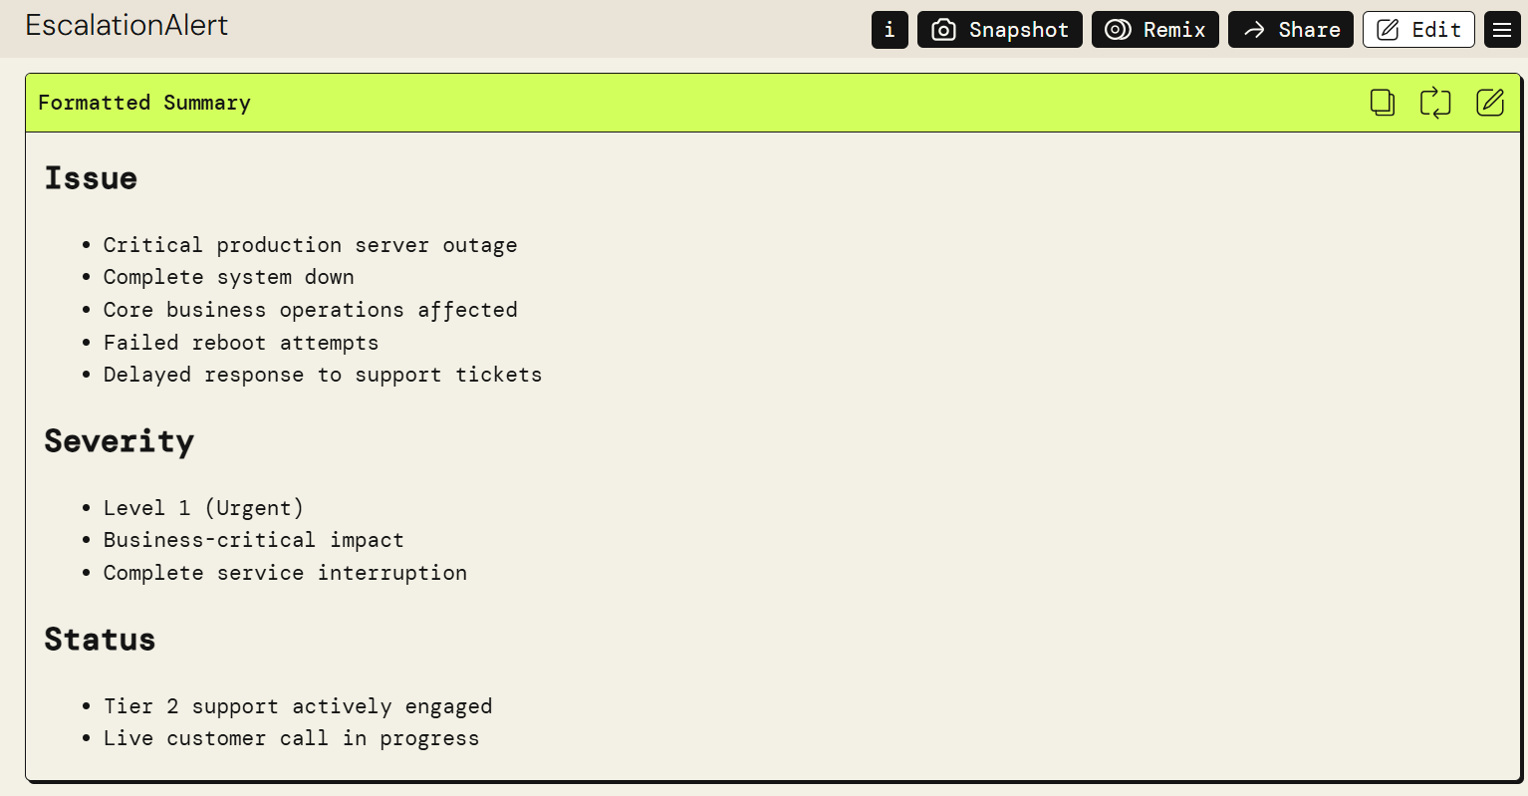

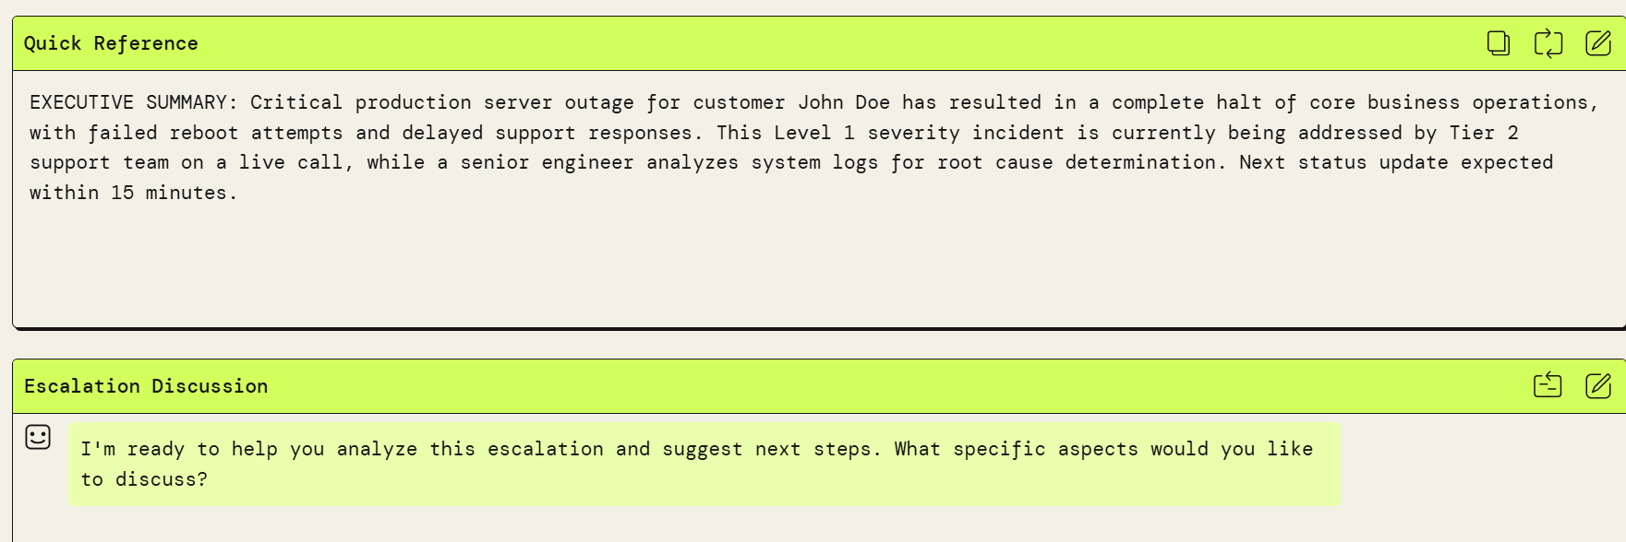

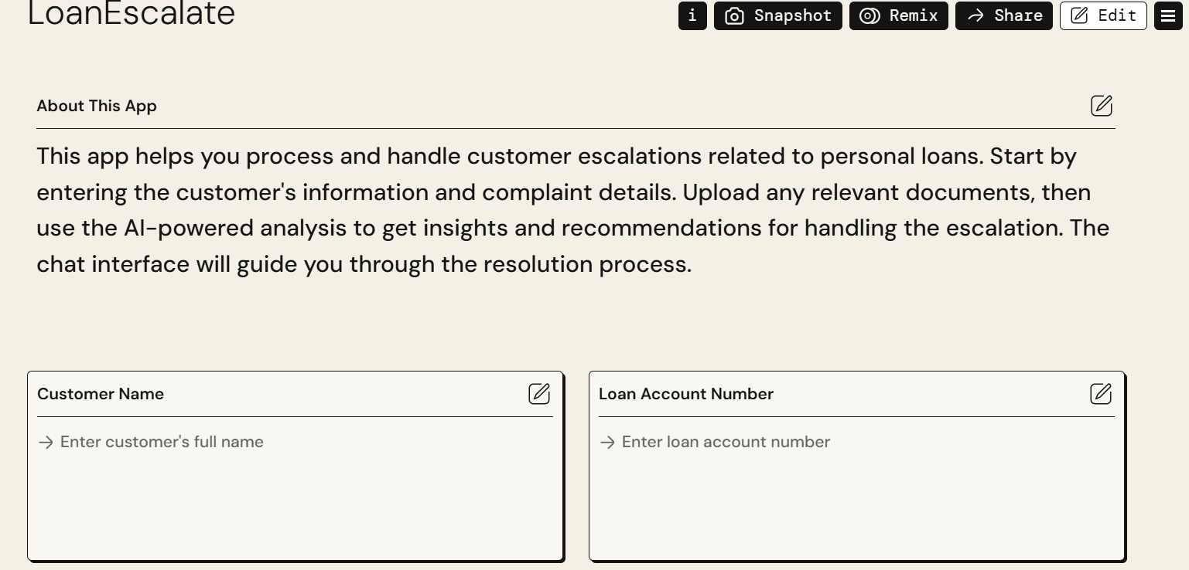

https://partyrock.aws/u/90017/7hM1Rs-fF/LoanEscalate/snapshot/MIU4fRtY8